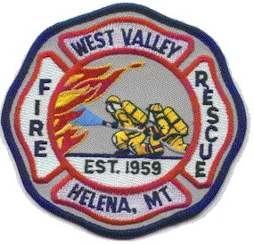

Agenda for January 2025 Trustee Meeting

The West Valley Fire Rescue Board of Trustees will meet on January 16th, 2025 at 7pm in the meeting room of West Valley Station 1 - 1165 Forestvale

- Opening of the meeting
Roll call
Reading and approval of the minutes of last months meeting
Communications

- Public Comment that is not on the agenda below

- Approval of warrants and financial reports

- Trustee and Officer reports

- New business
Further discussion on 6311 replacement

- Adjournment

_____________________________________________________________

Notice of the next Trustee Meeting

The West Valley Fire Rescue Board of Trustees
Next scheduled meeting is February 6th, 2025 at 7pm
To be held in the meeting room of Station 1 - 1165 Forestvale RD.

An agenda will be posted 48 hours prior to the meeting

