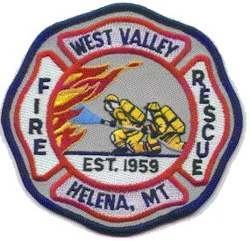

Agenda for September 2025 Trustee Meeting

The West Valley Fire Rescue Board of Trustees will meet on September 4th, 2025, at 7pm in the meeting room of West Valley Fire Rescue Station 1– 1165 Forestvale Rd.

- Opening of the meeting
Roll call
Reading and approval of the minutes of last month’s meeting
Communications

- Public Comment that is not on the agenda below

- Approval of warrants and financial reports

- Trustee and Officer reports

- New business

- Adjournment

_____________________________________________________________

Notice of the next Trustee Meeting

The West Valley Fire Rescue Board of Trustees
Next scheduled meeting is October 9th, 2025, at 7pm
To be held in the meeting room of Station 1 - 1165 Forestvale RD.

An agenda will be posted 48 hours prior to the meeting

